Statistics For Data Science :

What is .ipynb extension : **IPython Notebook**

The **.ipynb** file extension stands for **IPython Notebook**, which is a file format used by **Jupyter Notebook**. Here's a breakdown of what it is:

**What is a .ipynb file?**

* **Purpose**: It is a JSON-based file format that stores the content of a Jupyter Notebook.
* **Contents**:
  + **Code cells**: Contain executable code in languages like Python, R, Julia, etc.
  + **Markdown cells**: Contain formatted text, headings, and explanations.
  + **Output**: Stores the output generated by running the code, such as graphs, images, or textual results.
  + **Metadata**: Information about the notebook, such as its kernel and configurations.

**Use of .ipynb:**

* **Interactive Coding**: Allows users to write and run code interactively.
* **Data Visualization**: Integrates code, results, and visualizations in one place.
* **Sharing**: Easy to share with others for collaborative development or education.

**Population Data**

* **Definition:** The complete set of all possible observations or measurements in a specific group or category. It includes every member of the group you're studying.
* **Example:** If you're studying the heights of all adults in a country, the population is the entire group of adults in that country.
* **Characteristics:**
  + Often very large or infinite, making it impractical to study directly.
  + Provides the most accurate representation since it includes every possible observation.
  + Parameters like **mean (μ)**, **standard deviation (σ)**, etc., are calculated for the entire population.
* **Challenges:**
  + Collecting data for an entire population is usually expensive, time-consuming, and sometimes impossible.

**Sample Data**

* **Definition:** A subset of the population data, selected to represent the population for analysis. It’s used when analyzing the entire population is impractical.
* **Example:** If you randomly select 1,000 adults from the country to study their heights, this subset is your sample.
* **Characteristics:**
  + More manageable in size compared to the population.
  + Parameters like **sample mean (x̄)** and **sample standard deviation (s)** are calculated.
  + Results obtained from a sample are used to infer or generalize about the population.
* **Sampling Methods:**
  + **Simple Random Sampling:** Every individual has an equal chance of being selected.
  + **Stratified Sampling:** The population is divided into subgroups, and samples are taken from each group.
  + **Systematic Sampling:** Selecting every nth individual from a list.
  + **Cluster Sampling:** Dividing the population into clusters and randomly selecting entire

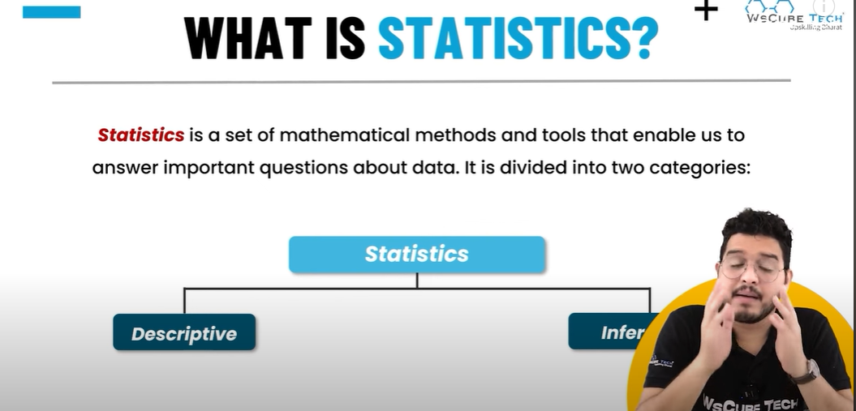

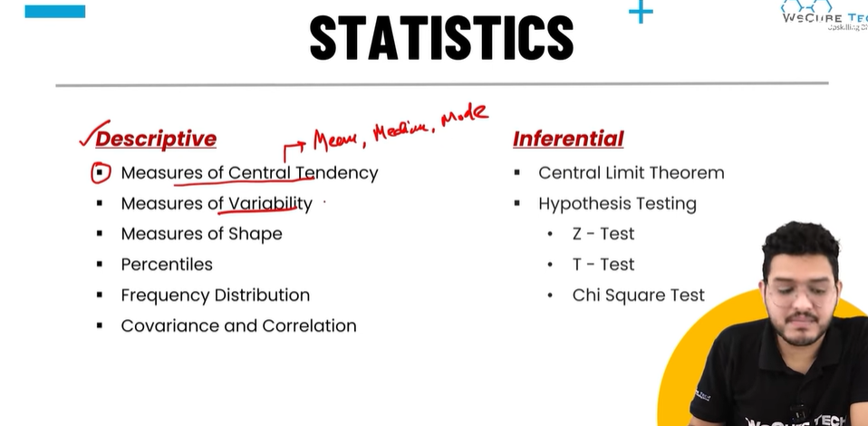

**Key Areas of Statistics in Data Science**

**1. Descriptive Statistics**

* **Purpose:** Summarize and describe the main features of a dataset.
* **Techniques:**
  + **Measures of Central Tendency:**
    - **Mean (Average):** Sum of values divided by the count.
    - **Median:** Middle value in a sorted dataset.
    - **Mode:** Most frequently occurring value.
  + **Measures of Dispersion:**
    - **Range:** Difference between the maximum and minimum values.

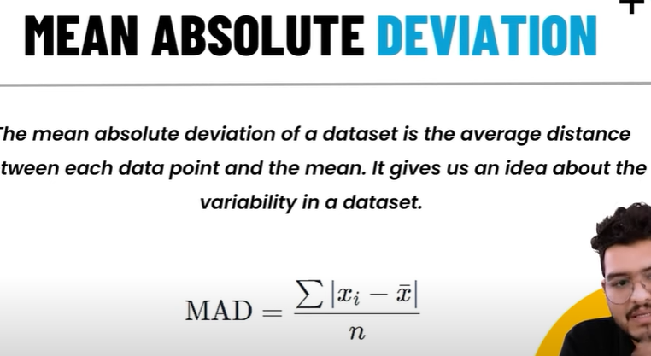

* + - **Variance:** Average squared deviation from the mean.

**Standard Deviation:** Square root of variance, indicating spread.

**Standard Deviation in Statistics**

**Standard deviation (SD)** is a measure of the amount of variation or dispersion in a dataset. It tells you how much the data points deviate, on average, from the **mean (average)** of the dataset.

**Why is Standard Deviation Important?**

1. **Measure of Spread:**
   * A **small standard deviation** means the data points are close to the mean (less spread out).
   * A **large standard deviation** means the data points are spread out over a wider range.
2. **Interpretation of Variability:**
   * Helps understand how consistent the data is.
   * Example: In a classroom, if test scores have a small standard deviation, most students performed similarly.

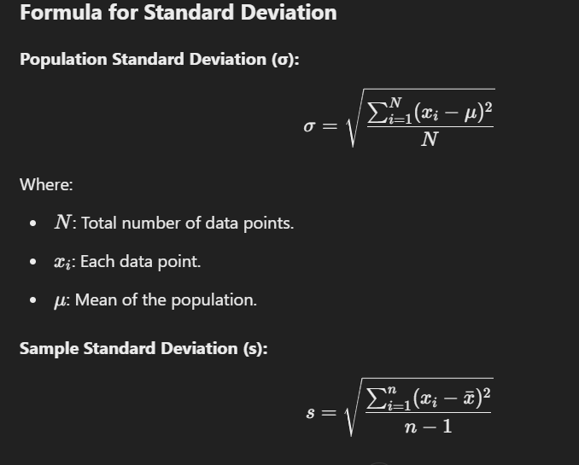

* + **Visualization Tools:**
    - Bar charts, histograms, box plots, scatter plots, etc.

**2. Inferential Statistics**

* **Purpose:** Draw conclusions about a population based on a sample.
* **Techniques:**
  + **Hypothesis Testing:**
    - Null Hypothesis (H₀): Assumes no effect or relationship.
    - Alternative Hypothesis (H₁): Assumes an effect or relationship exists.
    - **P-value:** Probability of observing the data under the null hypothesis.
    - Example: Testing if a new marketing strategy increases sales.
  + **Confidence Intervals:**
    - Range of values within which the population parameter likely lies.
  + **T-tests & Z-tests:**
    - Compare means of two groups.
  + **Chi-Square Test:**
    - Tests relationships between categorical variables.
  + **ANOVA (Analysis of Variance):**
    - Compares means across multiple groups.

**3. Probability Theory**

* **Purpose:** Model uncertainty and randomness in data.
* **Key Concepts:**
  + **Random Variables:** Variables with unpredictable outcomes (e.g., dice rolls).
  + **Probability Distributions:**
    - **Discrete:** Binomial, Poisson.
    - **Continuous:** Normal, Exponential.
  + **Bayes' Theorem:** Calculates conditional probabilities.
  + Example: Estimating the likelihood of customer churn.

**4. Statistical Modeling**

* **Purpose:** Build models to describe relationships between variables.
* **Common Models:**
  + **Linear Regression:**
    - Models the relationship between a dependent variable and one or more independent variables.
  + **Logistic Regression:**
    - Models binary outcomes (e.g., yes/no, success/failure).
  + **Time Series Analysis:**
    - Models data points collected over time.
  + **Clustering:**
    - Groups data points based on similarity.

**5. Experimental Design**

* **Purpose:** Plan experiments to test hypotheses effectively.
* **Techniques:**
  + Randomized experiments to reduce bias.
  + A/B testing to compare two versions of a product or service.
  + Factorial designs to evaluate multiple factors simultaneously.

**6. Sampling Techniques**

* **Purpose:** Collect representative subsets of the population.
* **Methods:**
  + Simple Random Sampling.
  + Stratified Sampling.
  + Cluster Sampling.
  + Systematic Sampling.
* Example: Choosing a representative group of customers for a survey.

**7. Data Distribution Analysis**

* **Purpose:** Understand the underlying distribution of the data.
* **Key Distributions:**
  + Normal Distribution: Symmetric "bell curve."
  + Skewed Distribution: Asymmetric (left or right skew).
  + Uniform Distribution: Equal probability for all outcomes.

**Percentages, Percentiles, and Quartiles in Data Analysis**

These are measures used to interpret data, understand distributions, and make comparisons. Let's break them down one by one.

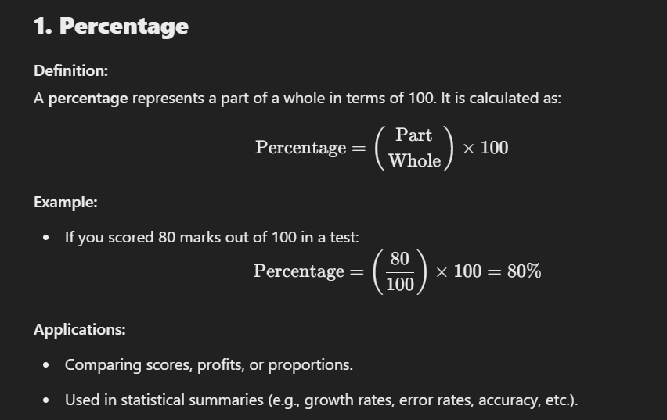

**2. Percentiles**

**Definition:**  
A **percentile** indicates the value below which a given percentage of data falls. It helps in understanding the relative standing of a data point within a dataset.

Percentile=Value such that P% of the data is less than or equal to it.\text{Percentile} = \text{Value such that P\% of the data is less than or equal to it.}Percentile=Value such that P% of the data is less than or equal to it.

**Key Points:**

* The **50th percentile** is the **median**.
* Percentiles range from 0 to 100.

**3. Quartiles**

**Definition:**  
Quartiles divide a dataset into **four equal parts**.  
Each quartile contains **25%** of the data.

**Key Quartiles:**

1. **Q1 (First Quartile):**
   * 25th percentile.
   * 25% of the data is less than Q1.
2. **Q2 (Second Quartile):**
   * 50th percentile (median).
   * 50% of the data is less than Q2.
3. **Q3 (Third Quartile):**
   * 75th percentile.
   * 75% of the data is less than Q3.

**Steps to Calculate Quartiles:**

1. **Sort the data** in ascending order.
2. Use the following formulas:
   * Q1Q1Q1: 25th percentile.
   * Q2Q2Q2: Median (50th percentile).
   * Q3Q3Q3: 75th percentile.
3. Use the same steps as percentiles to identify these positions.

How to detect outliear :

**Outlier Detection Using IQR (Interquartile Range)**

Outliers are data points that lie significantly outside the range of the majority of data. Detecting and handling outliers is crucial because they can skew results and mislead analysis. The **Interquartile Range (IQR)** is a robust method for identifying outliers.

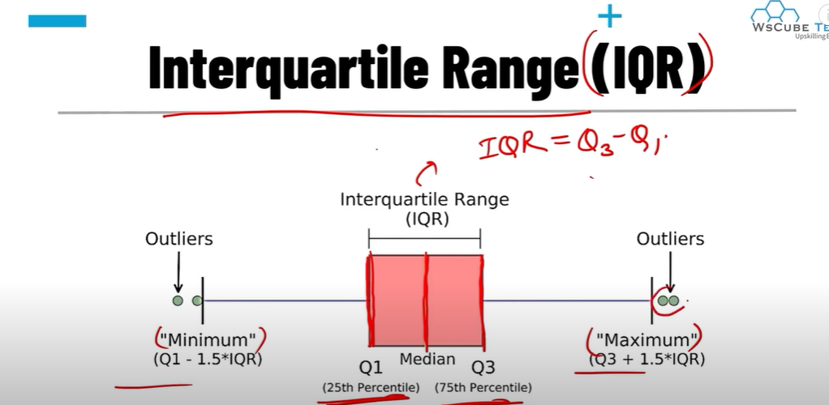

Gap between min,25%,50%,75% ,max is high it indicate that it having outliears . to avoid this mininmzing gap between it

Using boxplot in seaborn libreay we represent it easily

**\*\*Measures of Shape in Data Science\*\***

The **shape of a dataset** refers to the distribution of its values. Understanding the shape is crucial for interpreting data correctly and choosing the appropriate statistical or machine learning models. The measures of shape typically involve **skewness** and **kurtosis**.

**1. Skewness**

**Definition:**  
Skewness measures the asymmetry of a dataset's distribution.

* **Symmetric Distribution:** Skewness = 0 (e.g., a normal distribution).
* **Positive Skew (Right Skew):** Skewness > 0.
  + The right tail (higher values) is longer or fatter.
  + Example: Income distribution (many people earn low incomes, but a few earn very high incomes).
* **Negative Skew (Left Skew):** Skewness < 0.
  + The left tail (lower values) is longer or fatter.
  + Example: Test scores where most students score high, but a few score very low.

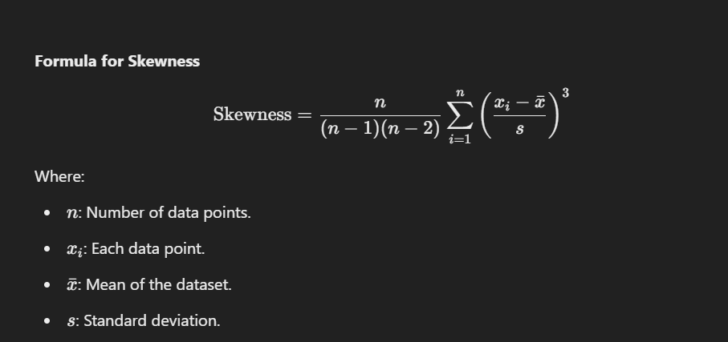

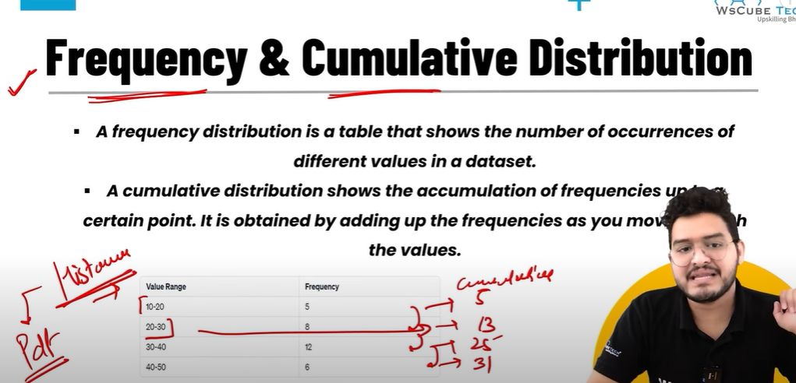

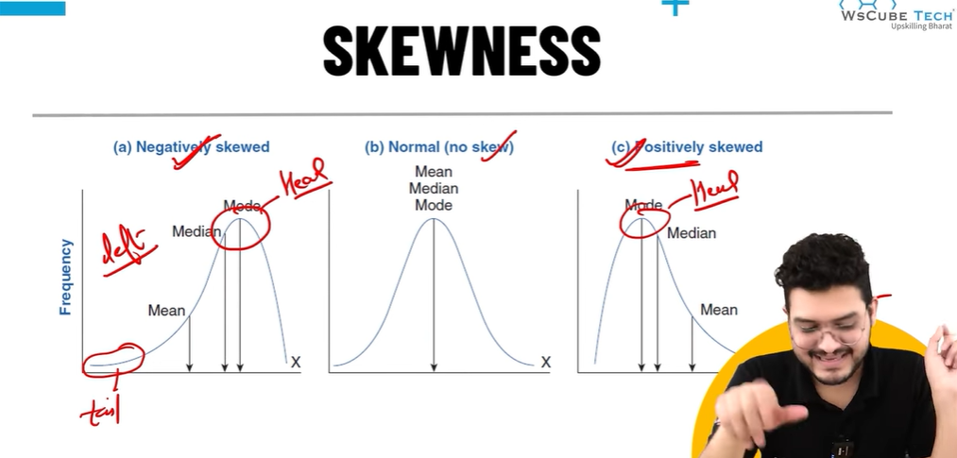

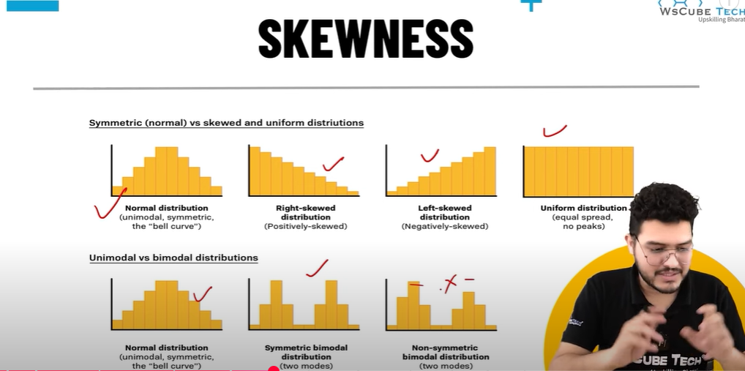

**2. Kurtosis**

**Definition:**  
Kurtosis measures the "tailedness" of a dataset's distribution. It describes whether the data has heavy or light tails compared to a normal distribution.

* **Mesokurtic:** Kurtosis = 3 (e.g., a normal distribution).
* **Leptokurtic:** Kurtosis > 3.
  + Heavy tails, more extreme values (outliers).
  + Example: Financial returns with occasional large changes.
* **Platykurtic:** Kurtosis < 3.
  + Light tails, fewer extreme values.
  + Example: Uniform distributions.

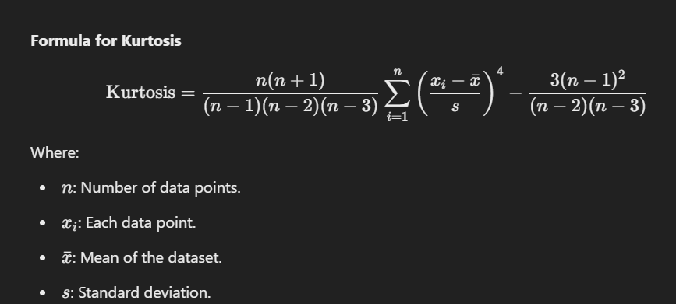

**Probability in Data Science**

**Probability** is the foundation of many concepts in data science. It quantifies the likelihood of events and helps data scientists make predictions, estimate uncertainty, and draw conclusions from data. Here's a breakdown of its role and applications:

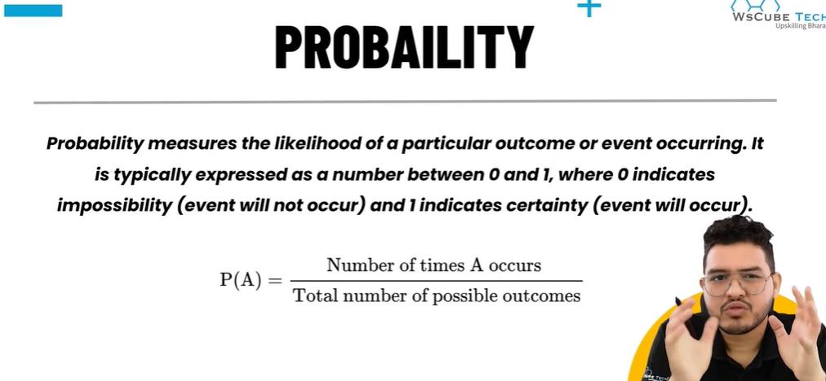

**1. Key Concepts in Probability**

**a) Random Experiment**

* A process with uncertain outcomes (e.g., rolling a dice, flipping a coin).

**b) Sample Space (S)**

* The set of all possible outcomes.
  + Example: For a coin toss, S={Head,Tail}

**c) Event (E)**

* A subset of outcomes from the sample space

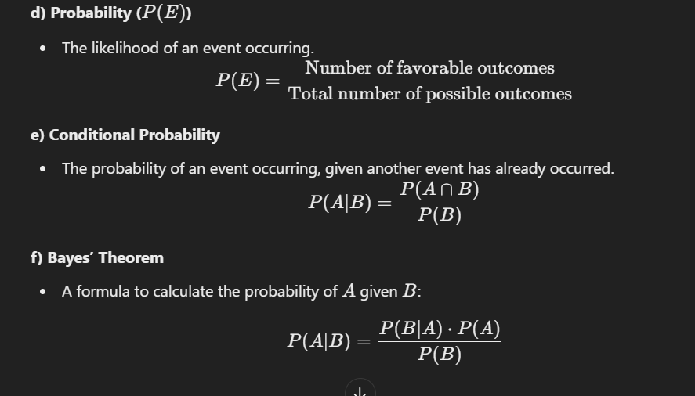

**Random Variables and Their Types**

In probability and statistics, a **random variable** is a variable that takes on numerical values determined by the outcomes of a random experiment. It is a bridge between a random event and numerical analysis.

**1. What is a Random Variable?**

A **random variable** assigns a numerical value to each possible outcome of a random experiment.

**Example:**

* Tossing a coin:
  + Assign X=1 for "Heads" and X=0for "Tails."
* Rolling a die:
  + Assign X={1,2,3,4,5,6}

A random variable is **not random** itself; it maps outcomes to numbers, enabling mathematical analysis.

**2. Types of Random Variables**

Random variables can be categorized into **discrete** and **continuous** types, depending on the set of possible values they can take.

**a) Discrete Random Variable**

* **Definition:** A random variable that can take on a **finite** or **countable** number of distinct values.
* **A random variable that take countable number of distint value**
* **Examples:**
  + Number of heads in 10 coin tosses.
  + Number of students in a class.
  + Number of cars sold in a day.
* **Key Features:**

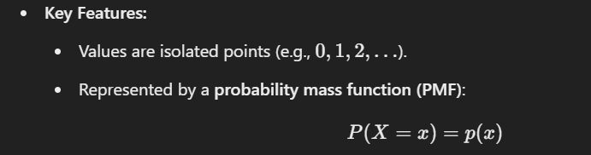

* **Example Distributions:**
  + **Bernoulli Distribution:** For a single binary outcome (success/failure).
  + **Binomial Distribution:** For multiple trials of a Bernoulli experiment.
  + **Poisson Distribution:**For the number of events in a fixed interval.

**b) Continuous Random Variable**

* **Definition:** A random variable that can take on an **infinite** number of values within a given range.
* **A random variable that can take on any value within a given range or interval**
* **Examples:**
  + Heights of people.
  + Time required to complete a task.
  + Temperature in a city.
* **Key Features:**
* 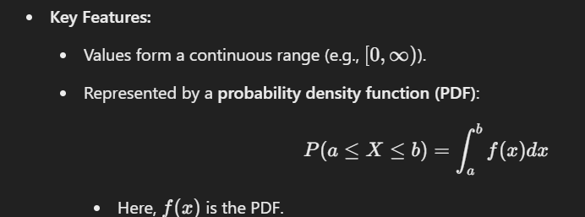
* **Example Distributions:**
  + **Normal Distribution:** Bell-shaped curve.
  + **Exponential Distribution:** Time between events in a Poisson process.
  + **Uniform Distribution:** Equal likelihood over a range.

**3. Differences Between Discrete and Continuous Random Variables**

| **Feature** | **Discrete** | **Continuous** |
| --- | --- | --- |
| **Values** | Countable (finite/infinite) | Infinite within a range |
| **Probability Function** | PMF: P(X=x)P(X = x)P(X=x) | PDF: P(a≤X≤b)P(a \leq X \leq b)P(a≤X≤b) |
| **Examples** | Number of heads, number of students | Height, wei |

Probabality disturbution :

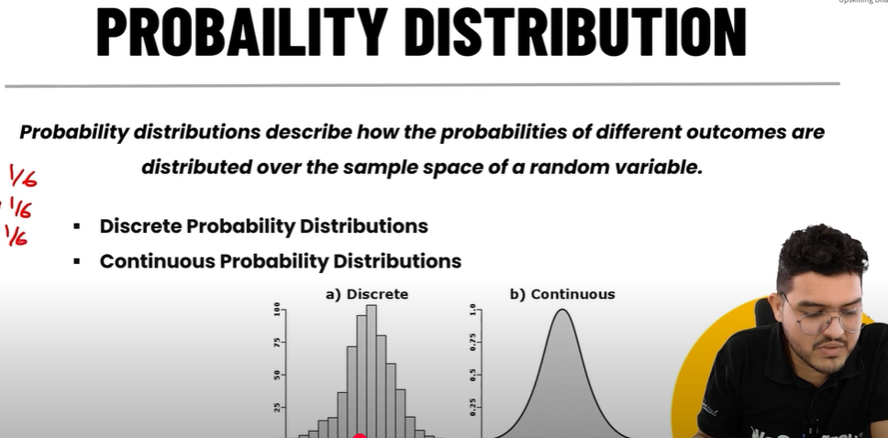

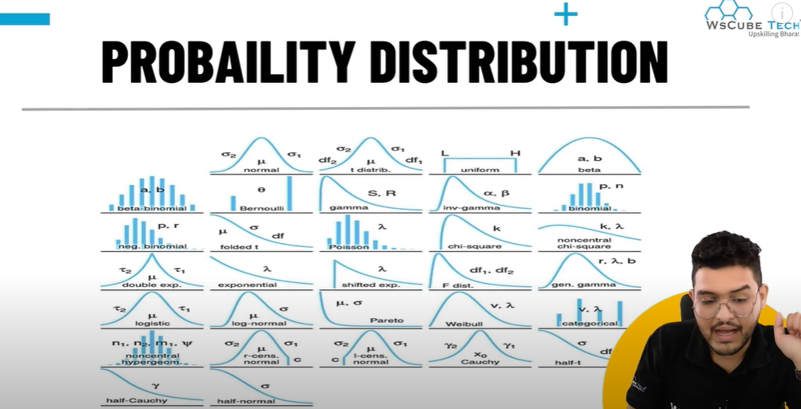

Probability function :

**Probability Function in Data Science**

A **probability function** is a mathematical function that describes the likelihood of different outcomes in a random experiment. It provides a way to quantify the probabilities of events for either **discrete** or **continuous** random variables.

**1. Types of Probability Functions**

**a) Probability Mass Function (PMF)**

* Used for **discrete random variables**.
* Represents the probability of the random variable taking a specific value.

P(X=x)=p

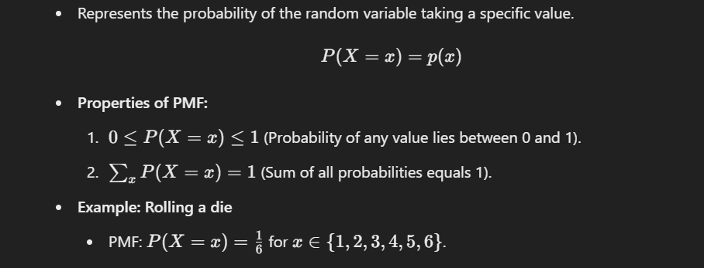

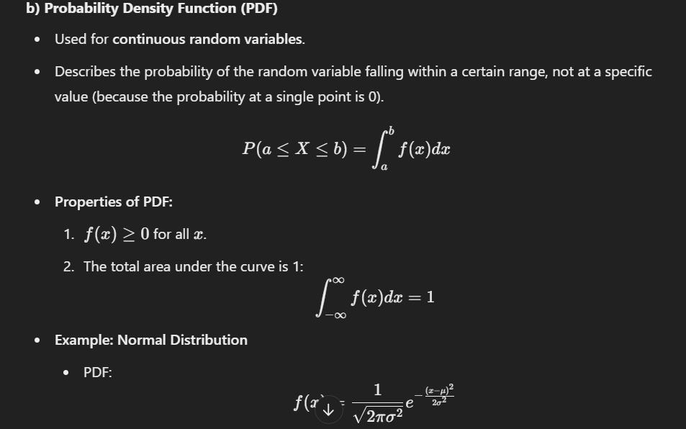

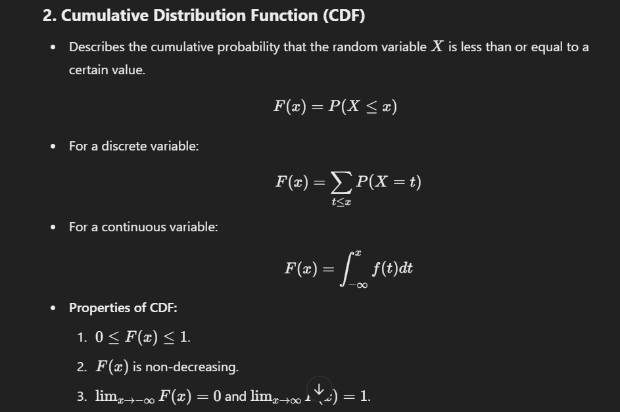

**Normal Distribution in Data Science**

The **Normal Distribution**, also known as the **Gaussian Distribution**, is one of the most commonly used probability distributions in data science, statistics, and machine learning. It is a continuous probability distribution that is symmetric about the mean, describing data that clusters around a central value.

**Key Characteristics**

1. **Symmetry**: The distribution is symmetric around the mean (μ\muμ).
2. **Mean, Median, Mode**: In a normal distribution, the mean, median, and mode are all equal.
3. **Bell Curve Shape**: The probability density function has a bell-shaped curve.
4. **Asymptotic**: The tails approach, but never touch, the x-axis.
5. **Empirical Rule** (68-95-99.7 Rule):
   * 68% of data falls within one standard deviation (σ\sigmaσ) of the mean.
   * 95% falls within two standard deviations.
   * 99.7% falls within three standard deviations.

**Formula**

The probability density function of a normal distribution is defined as:

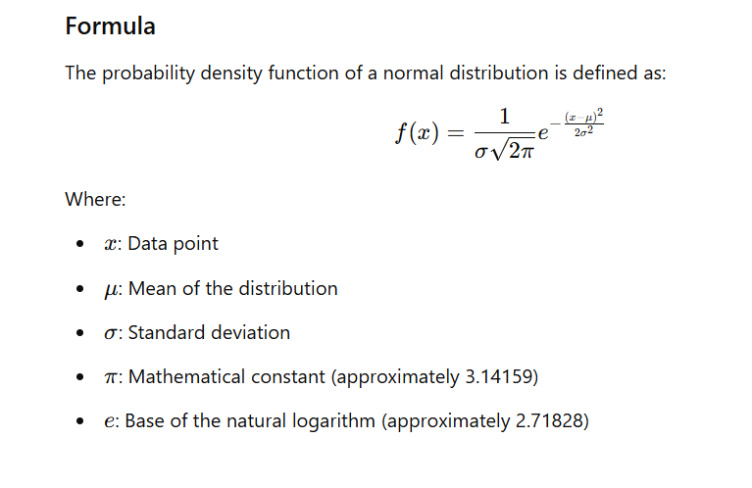

**Standard Normal Distribution**

The **Standard Normal Distribution** is a special case of the normal distribution where:

* The **mean (μ\muμ)** is 0.
* The **standard deviation (σ\sigmaσ)** is 1.

It is used extensively in statistics and data science for comparison, standardization, and statistical inference.

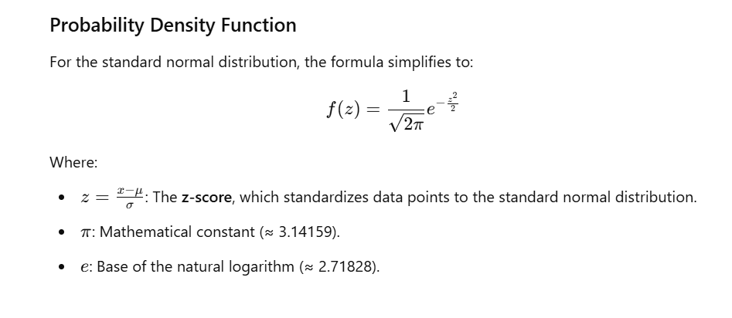

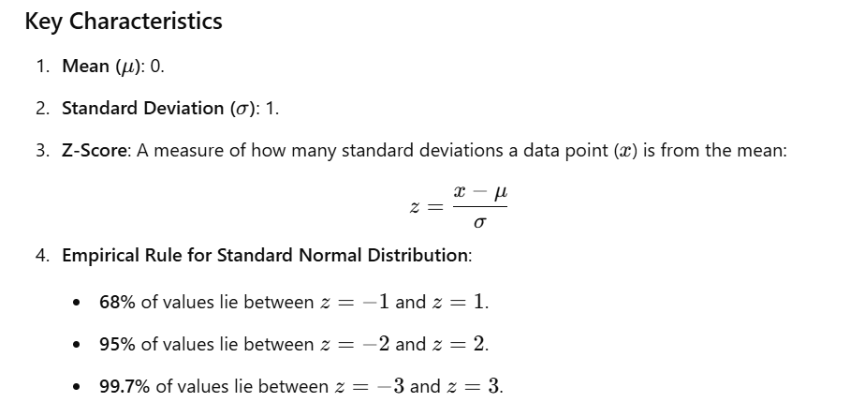

**Variance and Covariance are fundamental concepts in statistics that measure variability and relationships between variables. Here's a detailed explanation:**

**1. Variance**

* **Definition**: Variance measures how much a single variable deviates from its mean (average). It quantifies the spread or dispersion of data points in a dataset.

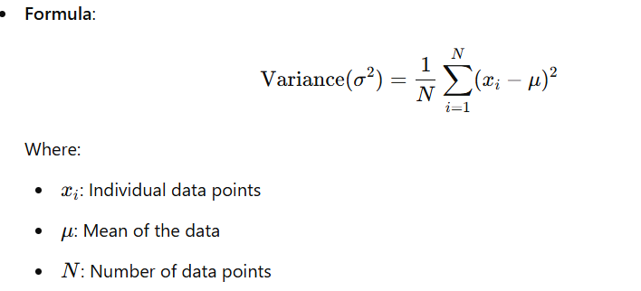

**Explanation**:

* If variance is **low**, the data points are close to the mean (less spread).
* If variance is **high**, the data points are more spread out.

**2. Covariance**

* **Definition**: Covariance measures the relationship between two variables and indicates how changes in one variable are associated with changes in another.

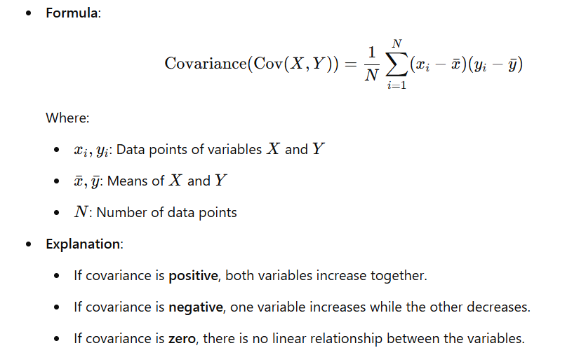

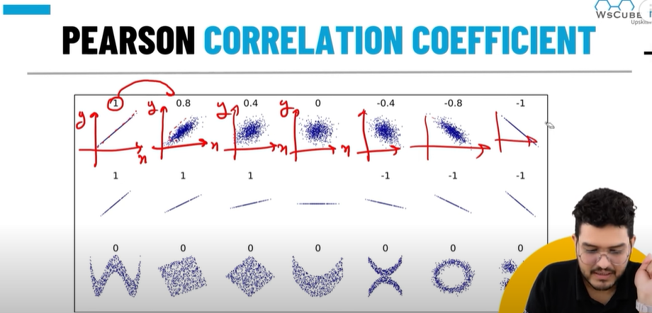

**Pearson Correlation Coefficient Overview**

The Pearson Correlation Coefficient, denoted as **rrr**, ranges from -1 to 1:

* r=1Perfect positive linear correlation.
* r=−1 Perfect negative linear correlation.
* r=0 No linear correlation.

**Understanding the Chart**

1. **Top Row (Scatter Plots)**:
   * Visual representation of data points for various values of rrr:
     + r=1 All points lie exactly on a straight line with a positive slope.
     + r=0.8 Points are closely clustered around a positive sloping line.
     + r=0.4 Points show a weaker positive relationship, more spread out.
     + r=0 No visible linear relationship between xxx and yyy.
     + r=−0.4,−0.8,−1milar logic applies for negative correlation, with decreasing rrr values indicating stronger negative linear relationships.
2. **Middle Row (Linear Representation)**:
   * These diagrams show the actual linear relationship corresponding to each scatter plot:
     + r=1 Strong upward line (perfect positive slope).
     + r=−1 Strong downward line (perfect negative slope).
     + r=0 No slope—flat line or random distribution.
3. **Bottom Row (Non-Linear Patterns)**:
   * Examples where r=0 out a non-linear relationship exists:
     + These include curved or cyclic patterns, such as a sine wave or a circular/elliptical pattern.
     + Although r=0, there **is** a relationship, but it is not linear. Pearson's rrr only captures linear relationships.

**Inplace=true**

In Python's **pandas** library, the inplace=True parameter is used in many methods to determine whether the operation modifies the object (like a DataFrame or Series) directly or returns a new object.

**Meaning of inplace=True**

* **When inplace=True**:
  + The operation modifies the object directly and does not return a new DataFrame or Series.
  + This can save memory since a new copy is not created.
* **When inplace=False (default)**:
  + The operation does not modify the object directly but returns a new object with the changes applied.
  + You need to assign the result back to update the original object.